OOP : Assignment
Name: Naman Sunil Bharsakale
Prn No: 255200003
Branch: Computer Science & Engineering (Aided)
Batch: S8
1. Given two integers, find an average of the integers.
Write a function:
double * ProblemSolution :: solution(int N1, int N2)
that accepts two integers and return the reference to the variable holding average.
Input
5
10
Input/Program Code:
#include <iostream>
using namespace std;

class ProblemSolution
{
public:

static double* solution(int N1,int N2)
{
double* average = new double(((double)N1 + (double)N2)/2);
return average;
}
};

int main()
{
int N1,N2;
cin>>N1>>N2;

double* result = ProblemSolution :: solution(N1,N2);
cout<<*result<<endl;

delete result;
return 0;

}
Output:
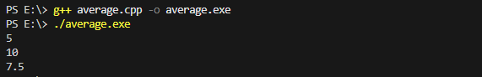

2. Given two integer pointers P1 and P2. Interchange values of P1 and P2.
Write a function:
void solution(int *P1, int *P2)
that accepts two integer pointers P1 and P2. The function should interchange values pointed by P1 and P2.
Input
4 10
Program Code:
#include <iostream>
using namespace std;
void Solution(int* P1, int* P2)
{
int t = *P1;
*P1 = *P2;
*P2 = t;
}
int main()
{
int a = 5, b = 6;
Solution(&a,&b);
cout<<a<<" "<<b<<endl;
return 0;

}
Output:
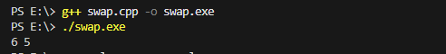

3. Given ProblemSolution class. Use a pointer to object of “ProblemSolution” class to invoke the “CalculateSum” and “Print” methods of “ProblemSolution”.
Write a function:
void Solution(int N1, int N2)
that accepts two integers N1 and N2. The function should instantiate “ProblemSolution” object with N1 and N2 values and call “CalculateSum” and “Print” method by creating a pointer to the object of “ProblemSolution”.
Program Code:
#include <iostream>
using namespace std;

class ProblemSolution{
int N1,N2,sum;
public:
ProblemSolution(int a , int b) { N1 = a; N2 = b; }
void CalculateSum() { sum = N1 + N2;}
void Print(){ cout<<"Sum: "<<sum; }
};
int main()
{
ProblemSolution a(5,6);
ProblemSolution* ptr = &a;
ptr -> CalculateSum();
ptr -> Print();

return 0;
}
Output:
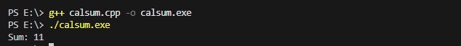
4. Given a CalculateSquare function.
Create a class 'ProblemSolution' with following characteristics
- A “solution” method which accepts an integer and returns an integer value.
- Create a pointer to function “CalculateSquare” outside the class and use that to invoke “CalculateSquare” method from “solution” function.
- A “solution” method should return the calculated square.

Input:
#include <iostream>
using namespace std;

int CalculateSquare(int x)
{
return x * x;
}

class ProblemSolution
{
public:
int Solution(int N){
int (*funcPtr) (int) = CalculateSquare;
return funcPtr(N);
}
};

int main()
{
ProblemSolution obj;
int result = obj.Solution(5);
cout<<result<<endl;
return 0;
}
Output:
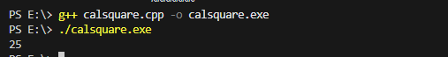

5. Given a class “Square”, implement “calculateArea” and “setLength” methods. Use “this pointer” to assign values to length (L).
- “setLength” method will set a value to member variable L.
- “calculateArea” will calculate and return area of the square (L*L).
Input:
#include <iostream>
using namespace std;

class Square {
private:
int L;

public:
void setLength(int L) {
this->L = L;
}

int calculateArea() {
return L * L;
}
};

int main() {
int inputLength;
cin >> inputLength;

Square s;
s.setLength(inputLength);
cout << s.calculateArea();

return 0;
}

Output:
